**Module 1:**

**Effective Communication Task:**

Write professional emails based on any 5 of the following scenarios. Ensure clarity, conciseness, and a formal tone.

1. 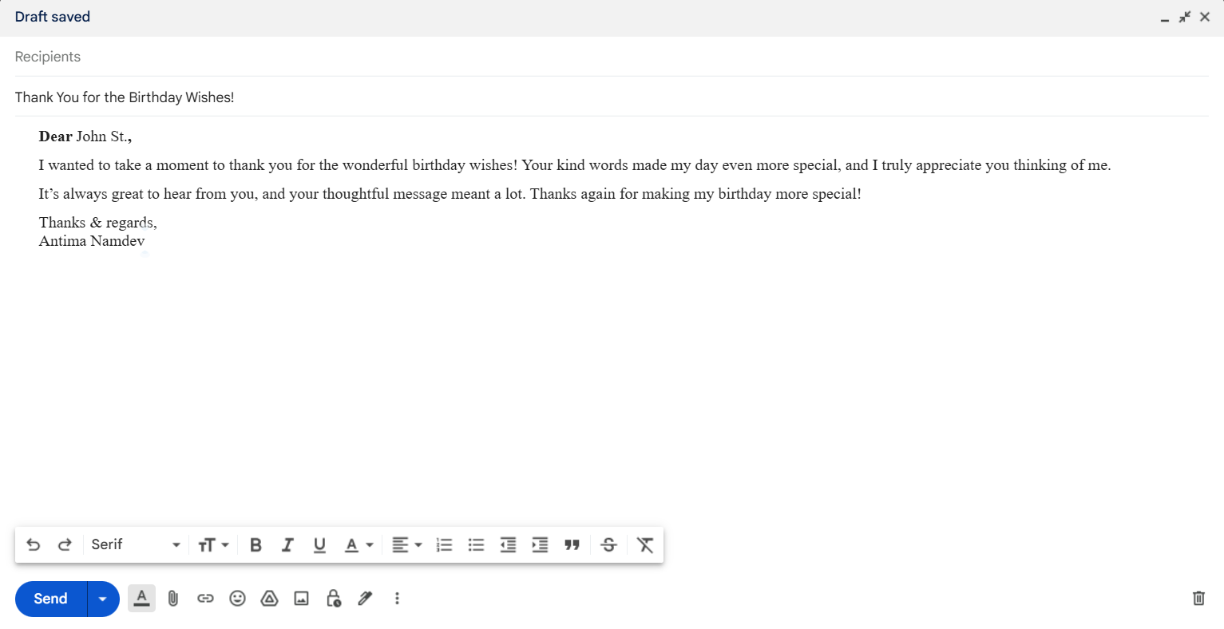**Thank you Email**
2. 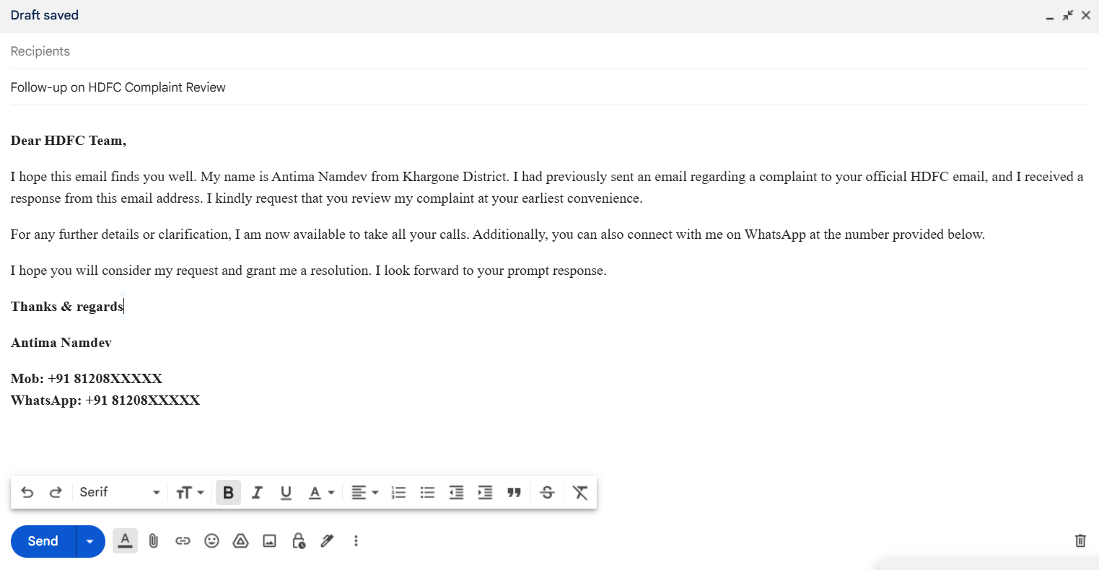**Reminder Email**
3. **Email of Inquiry for Requesting Information**

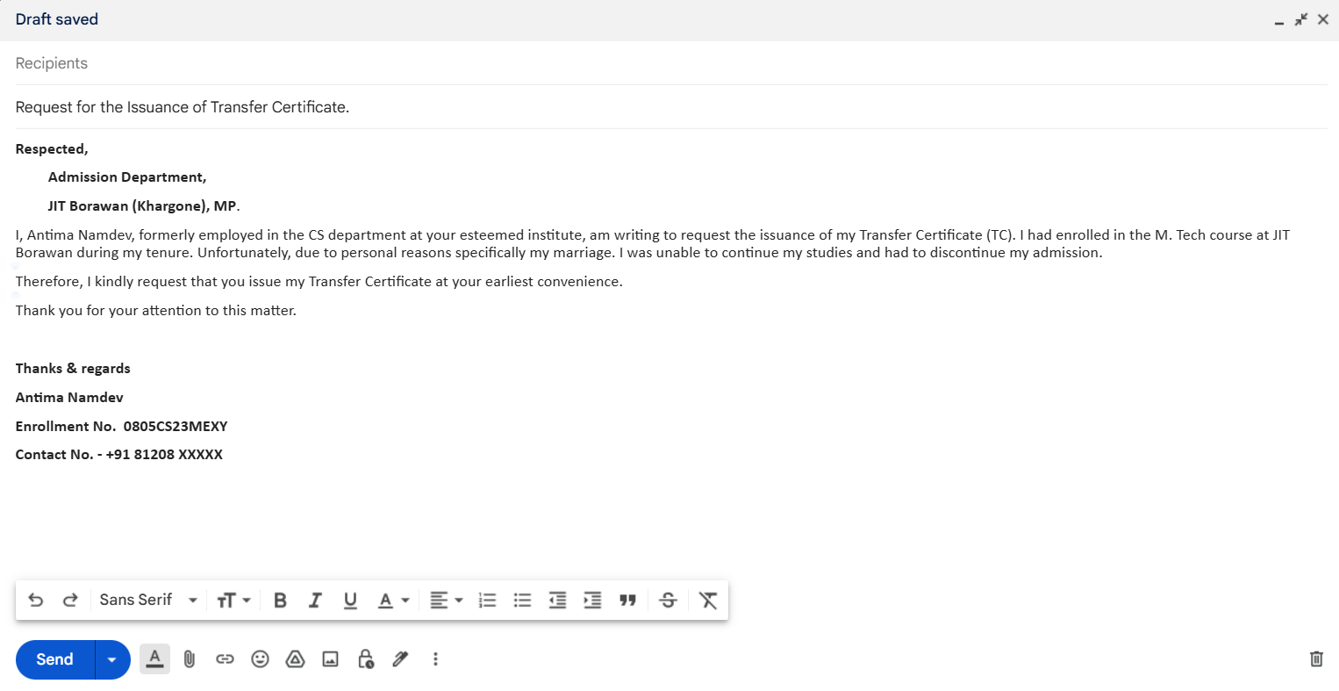

1. 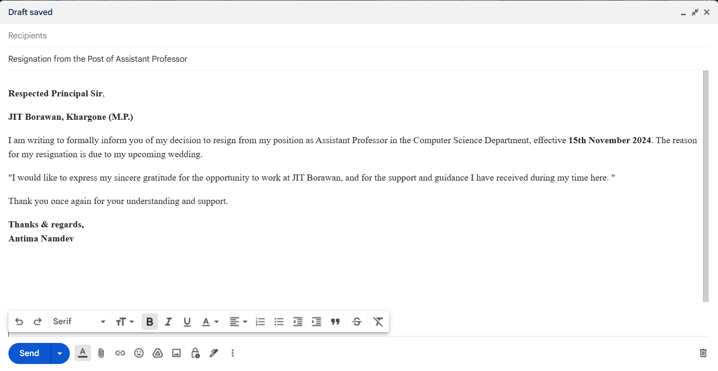 **Resignation Email**
2. **Introduction Email to Client**

